High Ground Organics

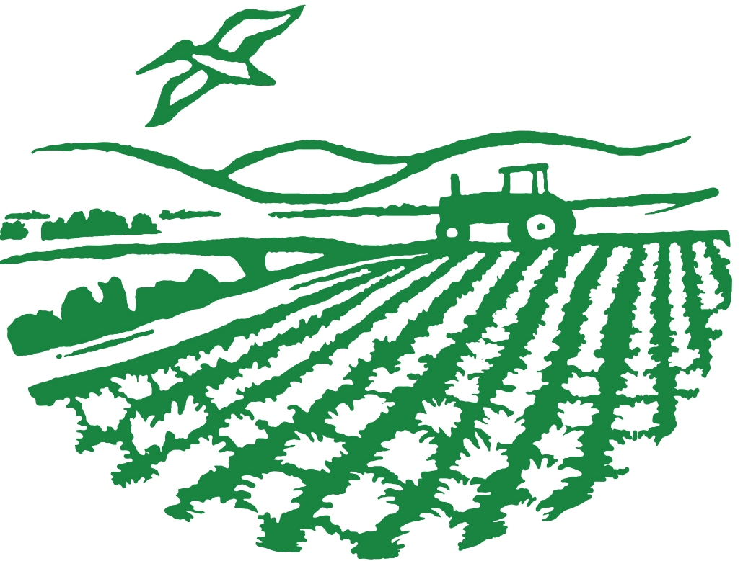

Community Supported Agriculture

Week W4, January 20th and 21st, 2016

(No) Complaints about the Rain, by Steve Pedersen

Shortly after 5 am this morning, as I sat down in front of the computer to check the weather forecast, the possum that lives under our tub in the adjoining hall bathroom got into a fight with a skunk that wondered into the crawl space looking for shelter from the rain. I heard the whole thing transpire and ran into the bathroom stomping on the floor in an effort to break it up, but it was too late. The skunk let loose at full force, and now the entire house is permeated. The joys of rural living can be exaggerated at times.

This Week

Fennel
Radicchio
Escarole
Purple OR Chantenay Carrots
Beets
Mei Quin Choi
Broccoli
Winter Squash OR Tomatoes

Everything is certified organic. All vegetables and fruit were grown by High Ground Organics, except possibly some of the beets or winter squash from Coke Farm if we run short. Note: last minute substitutions may be made.
Equally unpleasant can be the task of harvesting in the middle of a major storm. These last two CSA weeks have been unlucky for us timing wise. Rainfall makes the harvest more difficult mainly in that we can’t get our truck anywhere near the crops being harvested without getting stuck in the mud. This means that the crew has to walk the produce out of the fields much further than they otherwise would. And the act of walking itself becomes increasingly difficult as the ground becomes saturated—especially here at our home ranch, with its heavy clay soils which build up on your boots until they feel like they were made of lead.
It’s not that we are complaining though. No, with the exception of the harvest difficulties, for us it is all good. The rainfall will help to recharge local aquifers, fill the sloughs, keep our cover-crops growing lush and tall, leach harmful salts from our soil, and give the surrounding native trees and shrubs the thorough deep soaking that they have been so desperately in need of these last three years.
The forecasters say the storms these last few weeks mark the official beginning of the “El Nino” winter storm cycle here. They have a more Western trajectory as opposed to the storms earlier this year which came down more from the North. As I understand it, the effects of this pattern will be somewhat complex. Because the storms are coming off the ocean, they will have a strong moisture tap, but they will be warmer than those that drop down from the Northwest. This will mean more rainfall, but potentially less snowpack in the Sierra which could have implications for water availability statewide later in the year.
At any rate, the rain is still welcome. We were well prepared for a wet year and our farm is certainly already the better for it. We just have to hold our nose and dive in.

NEXT WINTER DELIVERY:
February 3 & 4

Veggie Notes, by Sarah Brewer
Always rinse produce before use. Everything should be refrigerated except winter squash and tomatoes. Remove the greens from the root vegetables right away to keep crisp.
This week's box brings us a double dose of chicories, in both the striking magenta leaves of the radicchio and the fluffy, lettuce-like escarole. Understanding how to love the bitter is not always second-nature for many of us, as American cuisine tends to favor the sweet or salty ends of the flavor spectrum. But bitter has its place and these guys should be in their prime during the cooler months of winter. Aiding in appetite and digestion, bitters get those internal juices flowing in the gut and keep intestinal parasites at bay. Part of what makes them bitter is a substance called Lactucopicrin (Intybin) which also acts on the nervous system, in both a sedating and pain-relieving way. So, all these benefits are worth it if you can just get your tongue around it. Cook it down and mix with something rich to lessen the bite if you need to.
Fennel may be a bit of a challenge if you are not a fan of licorice flavor, and a fantastic treat if you are. The bulb will melt in your mouth if roasted or provide a crunch sliced thin in a salad.
Remember, beauty is skin deep for the purple carrots so a light scrub is better than peeling them if you want to retain the color.
I always think of Mei Quin Choi as something to sauté, but it can also be great raw in salads. Some thinly sliced Mei Quin and fennel with ribbons of radicchio in a lemony vinaigrette might just hit the spot these weeks when lettuce is M.I.A.
Broccoli is one of those superhero vegetables. Some of its superpowers, according to the World's Healthiest Vegetables website are cholesterol lowering, detoxification, Vitamin D balance and anti-inflammatory properties.

Cooking Notes, by Andrew Cohen
To my way of thinking, the contents of this week’s box mostly share an earthy quality along with varying amounts of bitterness on the parts of the radicchio, escarole, mei-quin, and even the carrots (especially if you get the purple ones). This calls for combining with sweet or bland elements to enhance the flavors. Radicchio, for many, is intensely bitter, so pairing with onions, fennel, and carrots works well, as does sautéing with balsamic vinegar or fig reduction. Bacon is also an excellent mitigant to radicchio’s bite. Escarole is milder, with the paler leaves being more tender and less sharp. The palest softest center leaves work in salads, while the whole head is excellent for sautéing. Fennel or carrot pair well in this case-see the recipe for carrots and escarole and use fennel instead of carrots. For mei-quin, a friend told me she uses it instead of celery sticks with peanut butter. This sounds great to me, and triggered the idea of a quick sauté of mei-quin with onion and carrot threads in a little coconut milk, ginger, and stock, and then drizzled with peanut sauce (see recipe for Bon-Bon sauce on site, skip the chili, lighten up a little on the sesame oil, and thin with a little water or coconut milk). Serve with jasmine rice or noodles. Thinking of nutty flavors, roast beets cut into chunks and sautéed with a touch of garlic and served with lots of crunchy chopped roasted almonds and/or pistachios makes a nice side dish right now. You could serve it alongside a braise of cubed pork shoulder or butt cooked with seared fennel wedges, olives, chunked carrots, onion, and fennel seed all cooked in Rioja wine. If you are looking for a hearty meat free dish that will feel like meat, cook up the roasted Portobellos with radicchio farro. The fennel pesto that accompanies the Roasted Carrots with Fennel Jam is quite versatile, and would serve well with chicken, fish, pork, pasta, grains, (deep breath in) and as a smear on sandwiches. Not to mention as a garnish for vegetables and soups. If desserts that blur the sweet/savory line tickle your taste buds, try a tarte with caramelized fennel and carrot with candied fennel seeds. If you want to go all out Italian, make the base with polenta. Do the entire recipe in a cast iron pan to produce a veg-centric dessert à la Tarte Tatin.
Note: We can’t print them all, but Chef Andrew’s recipes are always available in full at highgroundorganics.com.

Caramelized Carrots and Melted Escarole, from Chef Andrew E Cohen

1 bunch escarole, chopped and washed, leaving some water remaining on the leaves | 1 bunch carrots, cut into ¼ inch cubes
1 tablespoon sugar, or less | ½ tablespoon butter
Olive oil as needed | ½ tsp. fresh thyme, chopped
Salt and pepper to taste | Water as needed

Heat a 2 quart chef’s pan or 10 inch sauté pan over medium heat. When hot, sprinkle enough sugar on the pan bottom to just cover it. Cook until the sugar melts and is turning golden. Wait just until it starts to smell caramelized, then add the butter, thyme, and a little oil. Pick up the pan and swirl it to melt the pan and allow the pan to cool a little. Add the carrots and toss to coat with the caramel, then add enough water to cover the carrots by 1 inch. Bring to a simmer and cook the carrots until just tender all the way through. Use a slotted spoon to remove the carrots to a bowl and keep warm. Simmer the cooking liquid until reduced to ½ cup. Set pan aside.
As the carrots cook, heat a 10-inch sauté pan over medium-high heat. Lightly film the pan with oil. When hot, add the carrots, tossing to coat with oil. Sauté to heat through and add color to the cubes, crisping them a little. Add the escarole to the pan and season with salt and pepper. (If there is too much escarole to fit the pan without it falling out, add half, then when it wilts down, add the rest.) Toss to mix the carrots with the escarole and to get the escarole to the pan bottom. Cook until wilted, then add the remaining carrot cooking liquid, drizzling it all over. Toss the pan contents to coat with the liquid and cook until it reduces to a syrup.
Serve hot. Serves: 4

Roasted Portobello Chunks with Farro Radicchio Sauté, from Chef Andrew E Cohen
This is a dish with some substance, and the mushrooms make a good substitute for meat texturally and flavor-wise.

3-4 medium Portobello mushrooms, with pale gills and a lip that curls under somewhat, cut into 1-inch chunks | 2 medium to small heads radicchio, trimmed and cut into ¼ inch ribbons
1 small yellow or white onion cut into 3/16ths inch dice | 2-3 carrots, peeled and cut as above (1½ cups)
3 cups cooked farro | ¾ cup red wine vinegar
½ cup olive oil + more as needed | ½ cup balsamic vinegar
¼ TBS fresh marjoram, minced, or the needles from a 1-inch piece of rosemary, minced | ½ TBS + 1 tsp. fresh thyme, minced
3 cloves garlic, peeled, de-germed, minced | Salt and pepper to taste
Water if needed

In a non-reactive bowl, whisk together the vinegars, the ½ tablespoon thyme, marjoram or rosemary, some pepper, and 2/3rds of the garlic. Whisk in the ½ cup of oil, and then add the mushroom chunks, tossing to coat well. If a lot of the mushrooms are above the level of the marinade, add a little water so the marinade will cover the mushrooms. Allow to marinate for 1-3 hours.
Heat the oven to 425°F.
Heart a medium sauté pan over medium heat. When hot, film well with oil and add the carrots, onions, and teaspoon of thyme. Sauté until the onions are softened and starting to caramelize and the carrots are turning golden. Add the farro, adding oil to the mix just to coat the farro so it does not stick, and sauté until good and hot.
While the vegetables cook, drain the mushrooms, saving the marinade, and place on a foil lined sheet pan and place into the center of the oven. Cook for 12-15 minutes until they are cooked through-tender all the way through and starting to crisp on the edges. When done, remove from the oven and keep hot.
While the mushrooms cook, remove the farro and vegetables to a bowl, keep warm, and return the pan to the heat. Add a touch of oil and add the garlic. Cook until fragrant and softening a little. Add a tablespoon of the marinade to the pan and heat up. Add the radicchio to the pan and toss to coat. Cook until the radicchio wilts and becomes tender. Add more marinade and cook until it reduces to a syrup and coats the radicchio.
Add back the farro and vegetables and toss to combine well. Heat through.
The mushrooms should be done at this point. If there is any liquid from the mushrooms on the sheet pan, you can pour it into the farro and toss to distribute it. Put the farro onto a platter or plates, then top with the mushrooms. Serve hot.
Serves: 4

